

ASSIGNMENT 03

Aitzaz Tahir Ch 19p0012 SDA Bs(CS)-B



# Strategy Design Pattern

**Problem:**

Currently, there are two different classes each for Patient Login and Staff Login individually.

**Solution:**

By using the strategy design pattern, we can make it so depending on the login the user wants to see, we call that behavior from a single login class.

**Previous Class Diagram**

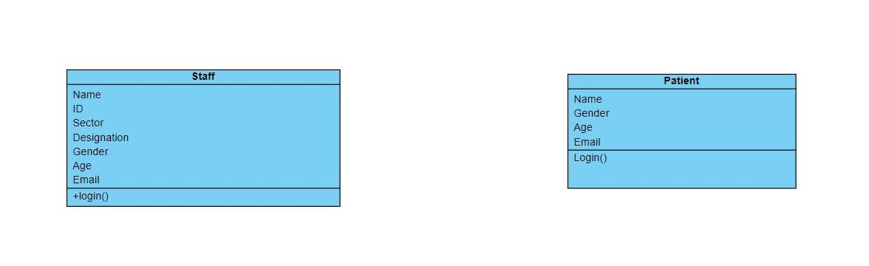

**Improved Class Diagram**

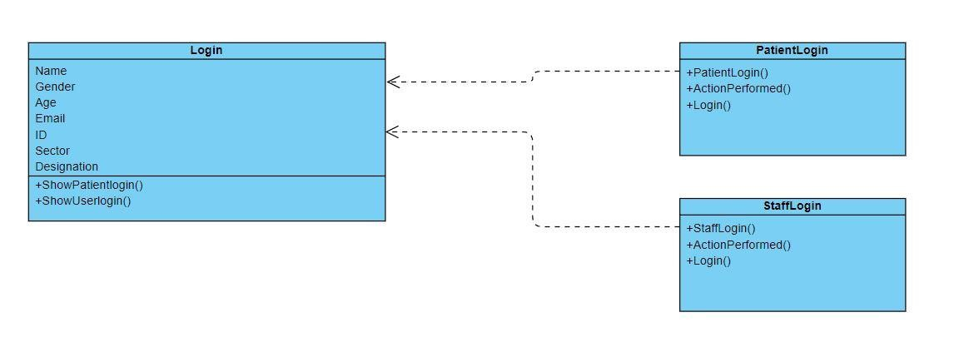

# 2) Builder Design Pattern

**Problem 1:**

There is a common functionality being used in all Mains right now which is the exit and logout functionality but this code is being replicated for all Mains.

**Solution 1:**

We can use the builder design pattern to create a parent class that initializes a frame with exit and logout functionality and then the children can add their extra functionality to it.

**Problem 2:**

We have a patient and a receptionist class that have very similar functionalities, i.e. creating a new user, booking an appointment and viewing appointments.

**Solution 2:**

We can also use the builder design pattern here and create a parent class which contains the common functionalities.

**Previous Class Diagram**

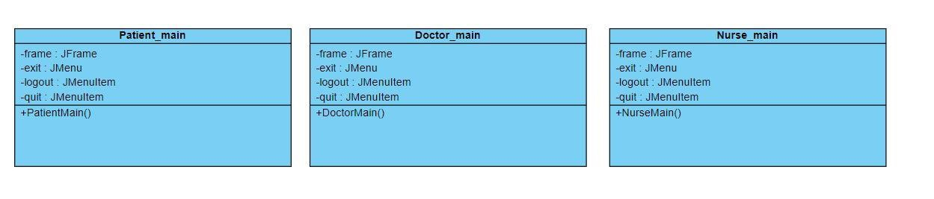

**Improved Class Diagram**

